**Canvas Setup Checklist**

During the first 3 weeks of school, Secondary teachers must work through the following for EACH of their Canvas Courses. Then meet with Steven Malan or Ellen Petersen to get each course signed off.

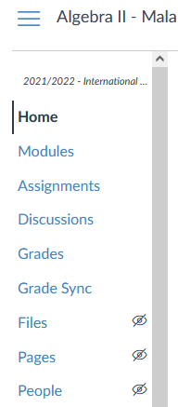

**1. Simple Navigation**

Your left-side navigation links should be simple and few. Only include what you will use.

Settings 🡪 Navigation 🡪 You will see two lists controlling what can/cannot be seen.

You probably do not need more than 5 buttons. For Middle school, even fewer.

You will still be able to see everything.

(Tip: “Grade Sync” is weird. You should make it “visible.” But that will only apply to you; the students cannot see it. It is very useful.)

**2. Parents Can Contact You**

If a parent logs on, they should EASILY be able to find your contact information. This could be a “contact me” section on the first page. If you use Modules as your “Homepage,” then include this information in the first module. If you have a traditional homepage, then include a “Contact Me” section on that homepage.

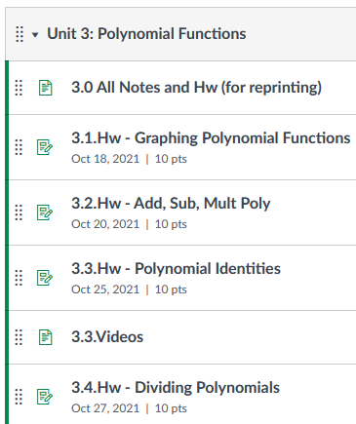**3. One Module Set Up**

Set up a module for at least one unit.

* It should have at least 3 entries.
* Use the “Unit.Lesson.Resource” format. Ask yourself, “If a student is lost and confused, could they find what they need?” Students should easily be able to find unit information, videos, homework, etc.
* Remember that you can include pages, homework assignments, tests, hyperlinks, videos, files, discussion links, and much more.
* Happy thought: Anything with a due date will show up on a student’s calendar and to-do list.

For help getting started, you can always work with Steven, Ellen, or your HOD.

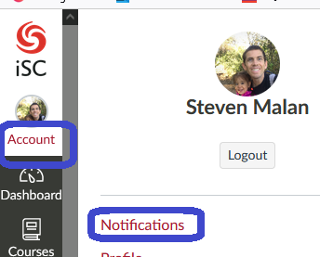**4. How Will You Get Notifications?**

You must know if a student:

* sends you a message on Canvas Inbox
* writes you a comment on an assignment

Go to your notification settings and choose how you would like to be notified for “Conversation Message” and “Submission Comments.”  
(I also like to be notified for “Late Grading,” when students turn in late work.)

You can choose how/when to get the notifications. But you must get them.

**5. Grade Sync Set Up with Nightly Sync Turned On**

Unless otherwise given permission, you should sync your Canvas Gradebook with PowerTeacher Pro. In General, the steps are:

a) First, set up your categories in PowerSchool.   
(Detailed Instructions on how to do this can be found in a separate PDF. Feel free to reach out for help. It can be confusing the first time.)

b) Import your categories into Canvas.   
(Detailed Instructions on how to do this can be found in a separate PDF. Feel free to reach out for help. It can be confusing the first time.)

c) Canvas left panel 🡪 Grade Sync 🡪 Utilities 🡪 Turn on “Nightly Sync”

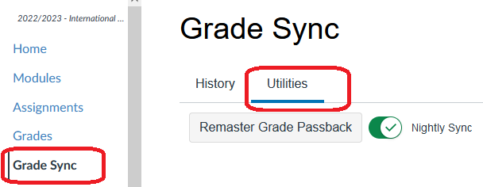

**6. Disable Final Grade View**

By default, Canvas will try to calculate students’ semester grades. You should turn this off.  
 Settings 🡪 Course Details 🡪 more options 🡪 Hide totals in student grades summary

Students will still be able to see individual assignment scores. But they should look to PowerSchool for their actual semester grade.

**7. Disable Low/High Grades**

By default, Canvas tells students what the lowest/highest grades are on any assignment. You should turn this off.

Settings 🡪 Course Details 🡪 more options 🡪 Hide grade distribution graphs from students

**8. Force English**

Throughout the year, you will say things like, “Go to ***Modules***,” or “Click on ***Next***.” If the student’s iPad/laptop language setting is not English (but it should be), these keywords will not be in English, making it harder for the students to follow along, and harder for you to help them when they get stuck. So set the course language to English:

Settings 🡪 Course Details 🡪 Scroll halfway down to Language 🡪 set to English

Most English vernacular used at our school is very American, so I suggest "English (United States)."

**9. Publish the Course!**

If you have not published yet, the publish button can be found in a few places:

On Dashboard: On “Homepage”

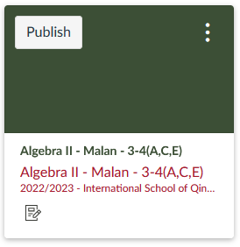 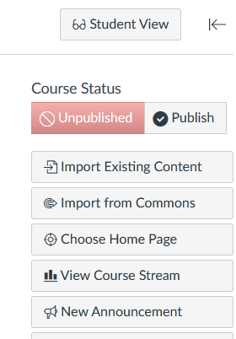

**10. Suggestions**

Canvas has so many powerful tools. Set a goal to learn one/some of them this year. Such as:

* Announcements
* Group work
* Peer review
* Speed Grader
* Panopto (for videos)

Suggestion: Change default assignment time (Settings 🡪 Default Due Time) to something right before your class. Then if you ever forget to set the time on an assignment, it will use this default, rather than 11:59pm.